**Lab 6 Report**

**Name: Wen Jun Student ID: 57118230**

Task 1: Get Familiar with SQL Statements

1. We have already setup MySQL in our SEEDUbuntu VM image. The username is root and password is seedubuntu. Please login to MySQL console using the following command:

$ mysql -u root -pseedubuntu

2. After login, you can create new database or load an existing one. As we have already created the Users database for you, you just need to load this existing database using the following command:

mysql> use Users;

3. To show what tables are there in the Users database, you can use the following command to print out all the tables of the selected database:

mysql> show tables;

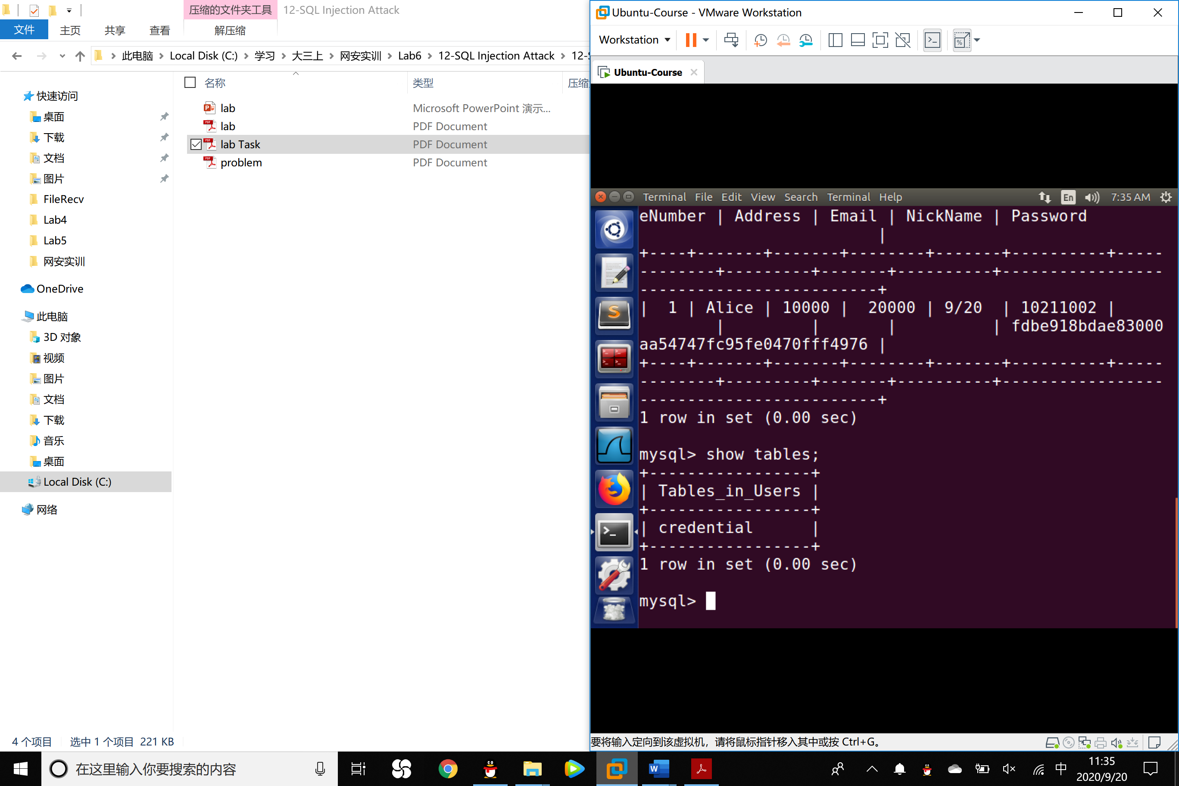

4. After running the commands above, you need to use a SQL command to print all the profile information of the employee Alice. Please provide the screenshot of your results.

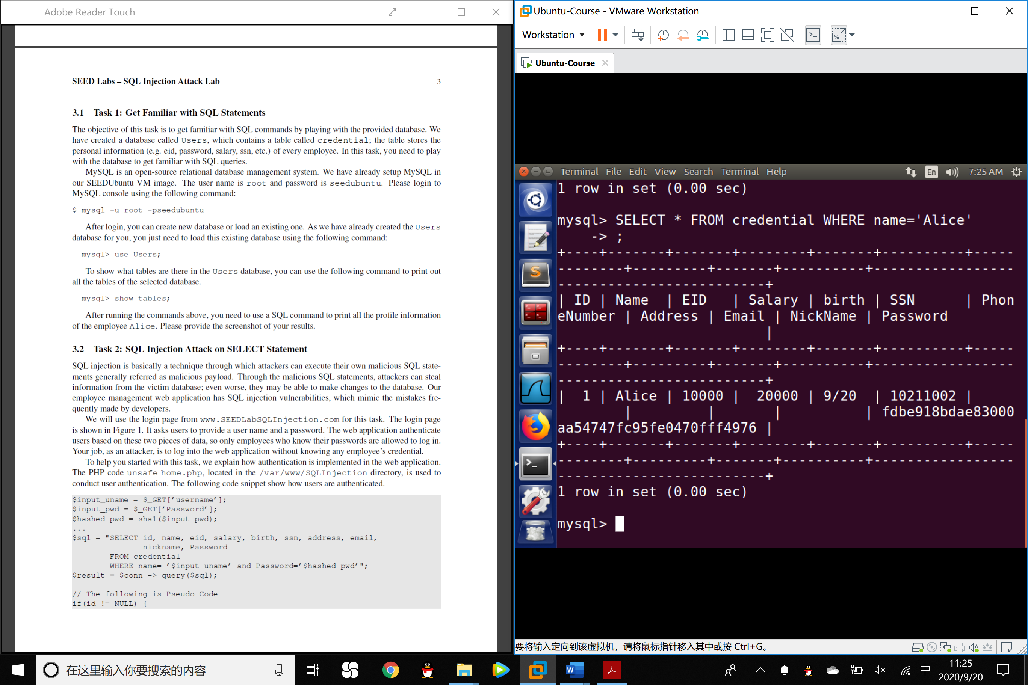

Task 2: SQL Injection Attack on SELECT Statement

SQL injection is basically a technique through which attackers can execute their own malicious SQL statements generally referred as malicious payload. Through the malicious SQL statements, attackers can steal information from the victim database; even worse, they may be able to make changes to the database.

We will use the login page from www.SEEDLabSQLInjection.com for this task. The login page asks users to provide a username and a password. The web application authenticates users based on these two pieces of data, so only employees who know their passwords are allowed to log in. Your job, as an attacker, is to log into the web application without knowing any employee’s credential.

1. **SQL Injection Attack from webpage**.

Your task is to log into the web application as the administrator from the login page, so you can see the information of all the employees. We assume that you do know the administrator’s account name which is admin, but you do not the password. You need to decide what to type in the Username and Password fields to succeed in the attack.

Experiment:

We input admin’# into the username line and we do not input any character into the password line. Then the SQL code the web server send to the database becomes

SELECT id, name, eid, salary, birth, ssn, address, email, nickname, Password

FROM credential

WHERE name= ’admin’#’ and Password=’ ’;

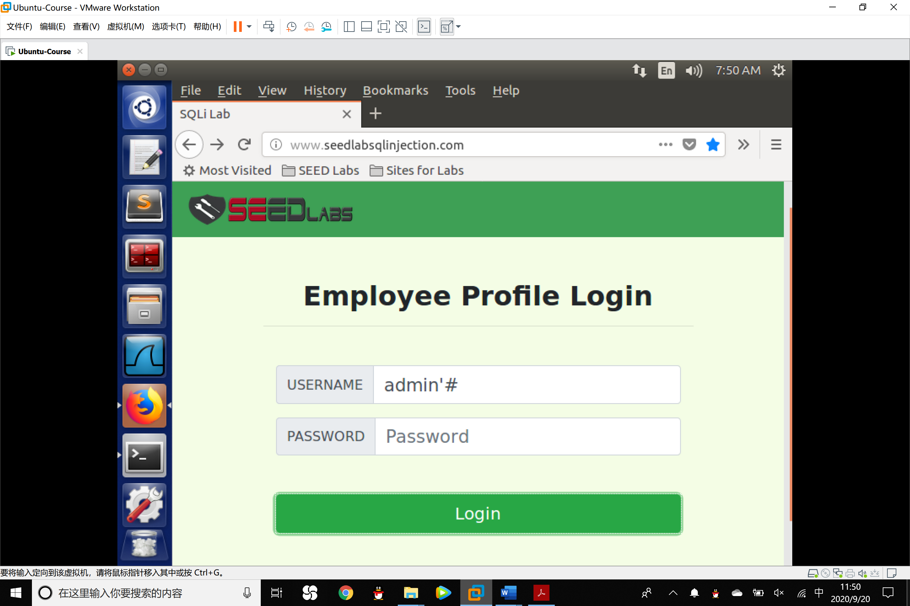

In this way, the password part will be commented by the # character so that the database will return the data of admin and we do not need to know the password to log into the account.

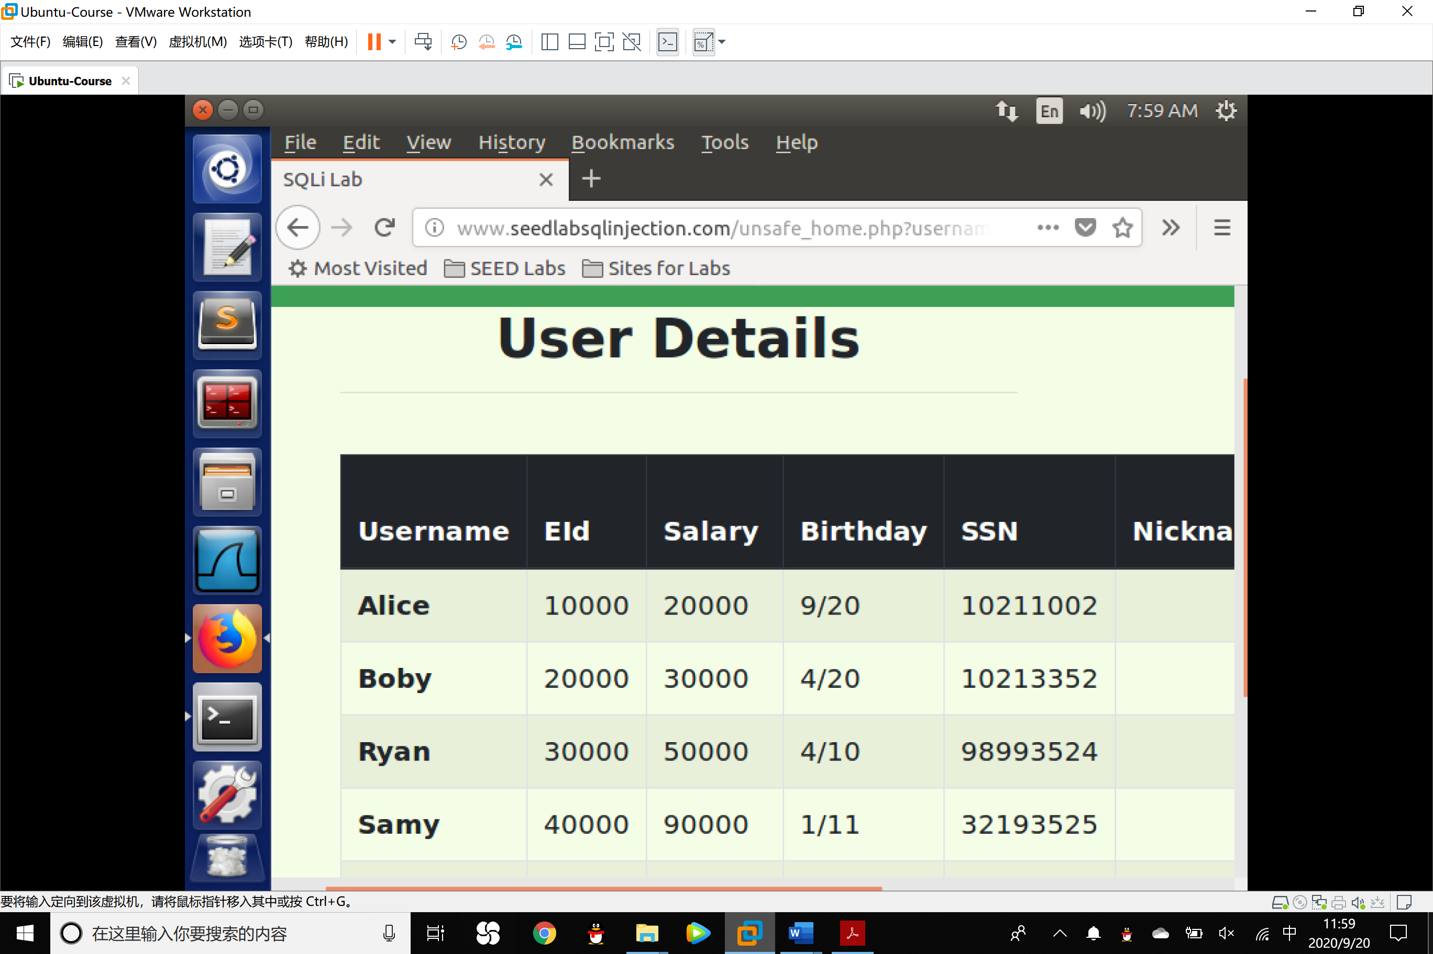

We have successfully log into the account of admin.

2. **SQL Injection Attack from command line**

Your task is to repeat Task 2.1, but you need to do it without using the webpage. You can use command line tools, such as curl, which can send HTTP requests. One thing that is worth mentioning is that if you want to include multiple parameters in HTTP requests, you need to put the URL and the parameters between a pair of single quotes; otherwise, the special characters used to separate parameters (such as &) will be interpreted by the shell program, changing the meaning of the command.

If you need to include special characters in the username or Password fields, you need to encode them properly, or they can change the meaning of your requests. If you want to include single quote in those fields, you should use %27 instead; if you want to include white space, you should use %20. In this task, you do need to handle HTTP encoding while sending requests using curl.

Experiment:

1. Using the curl to make the request and mind the encoding details.

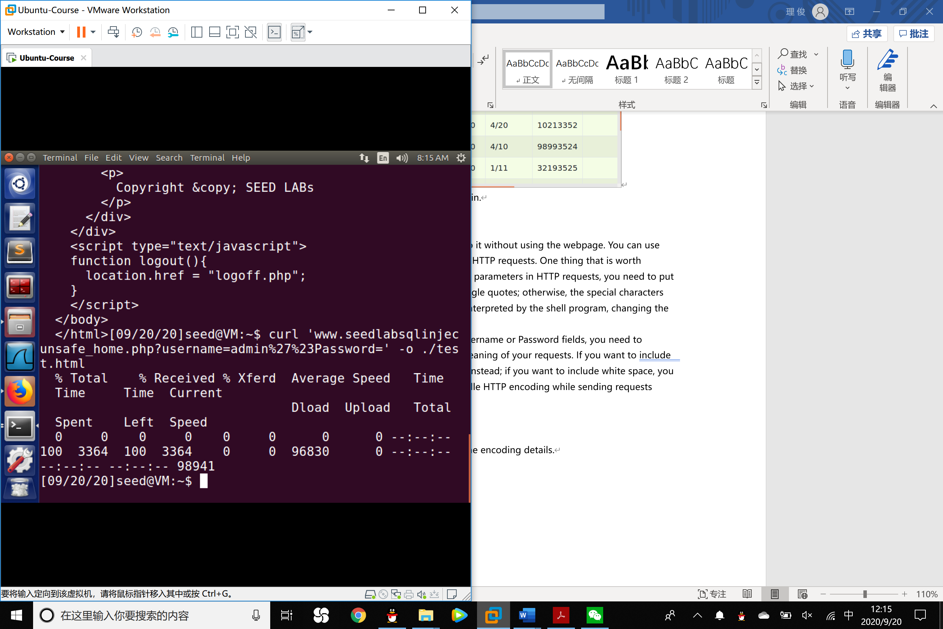

2. Save the response into test.html, open the test.html file in the /home/seed directory.

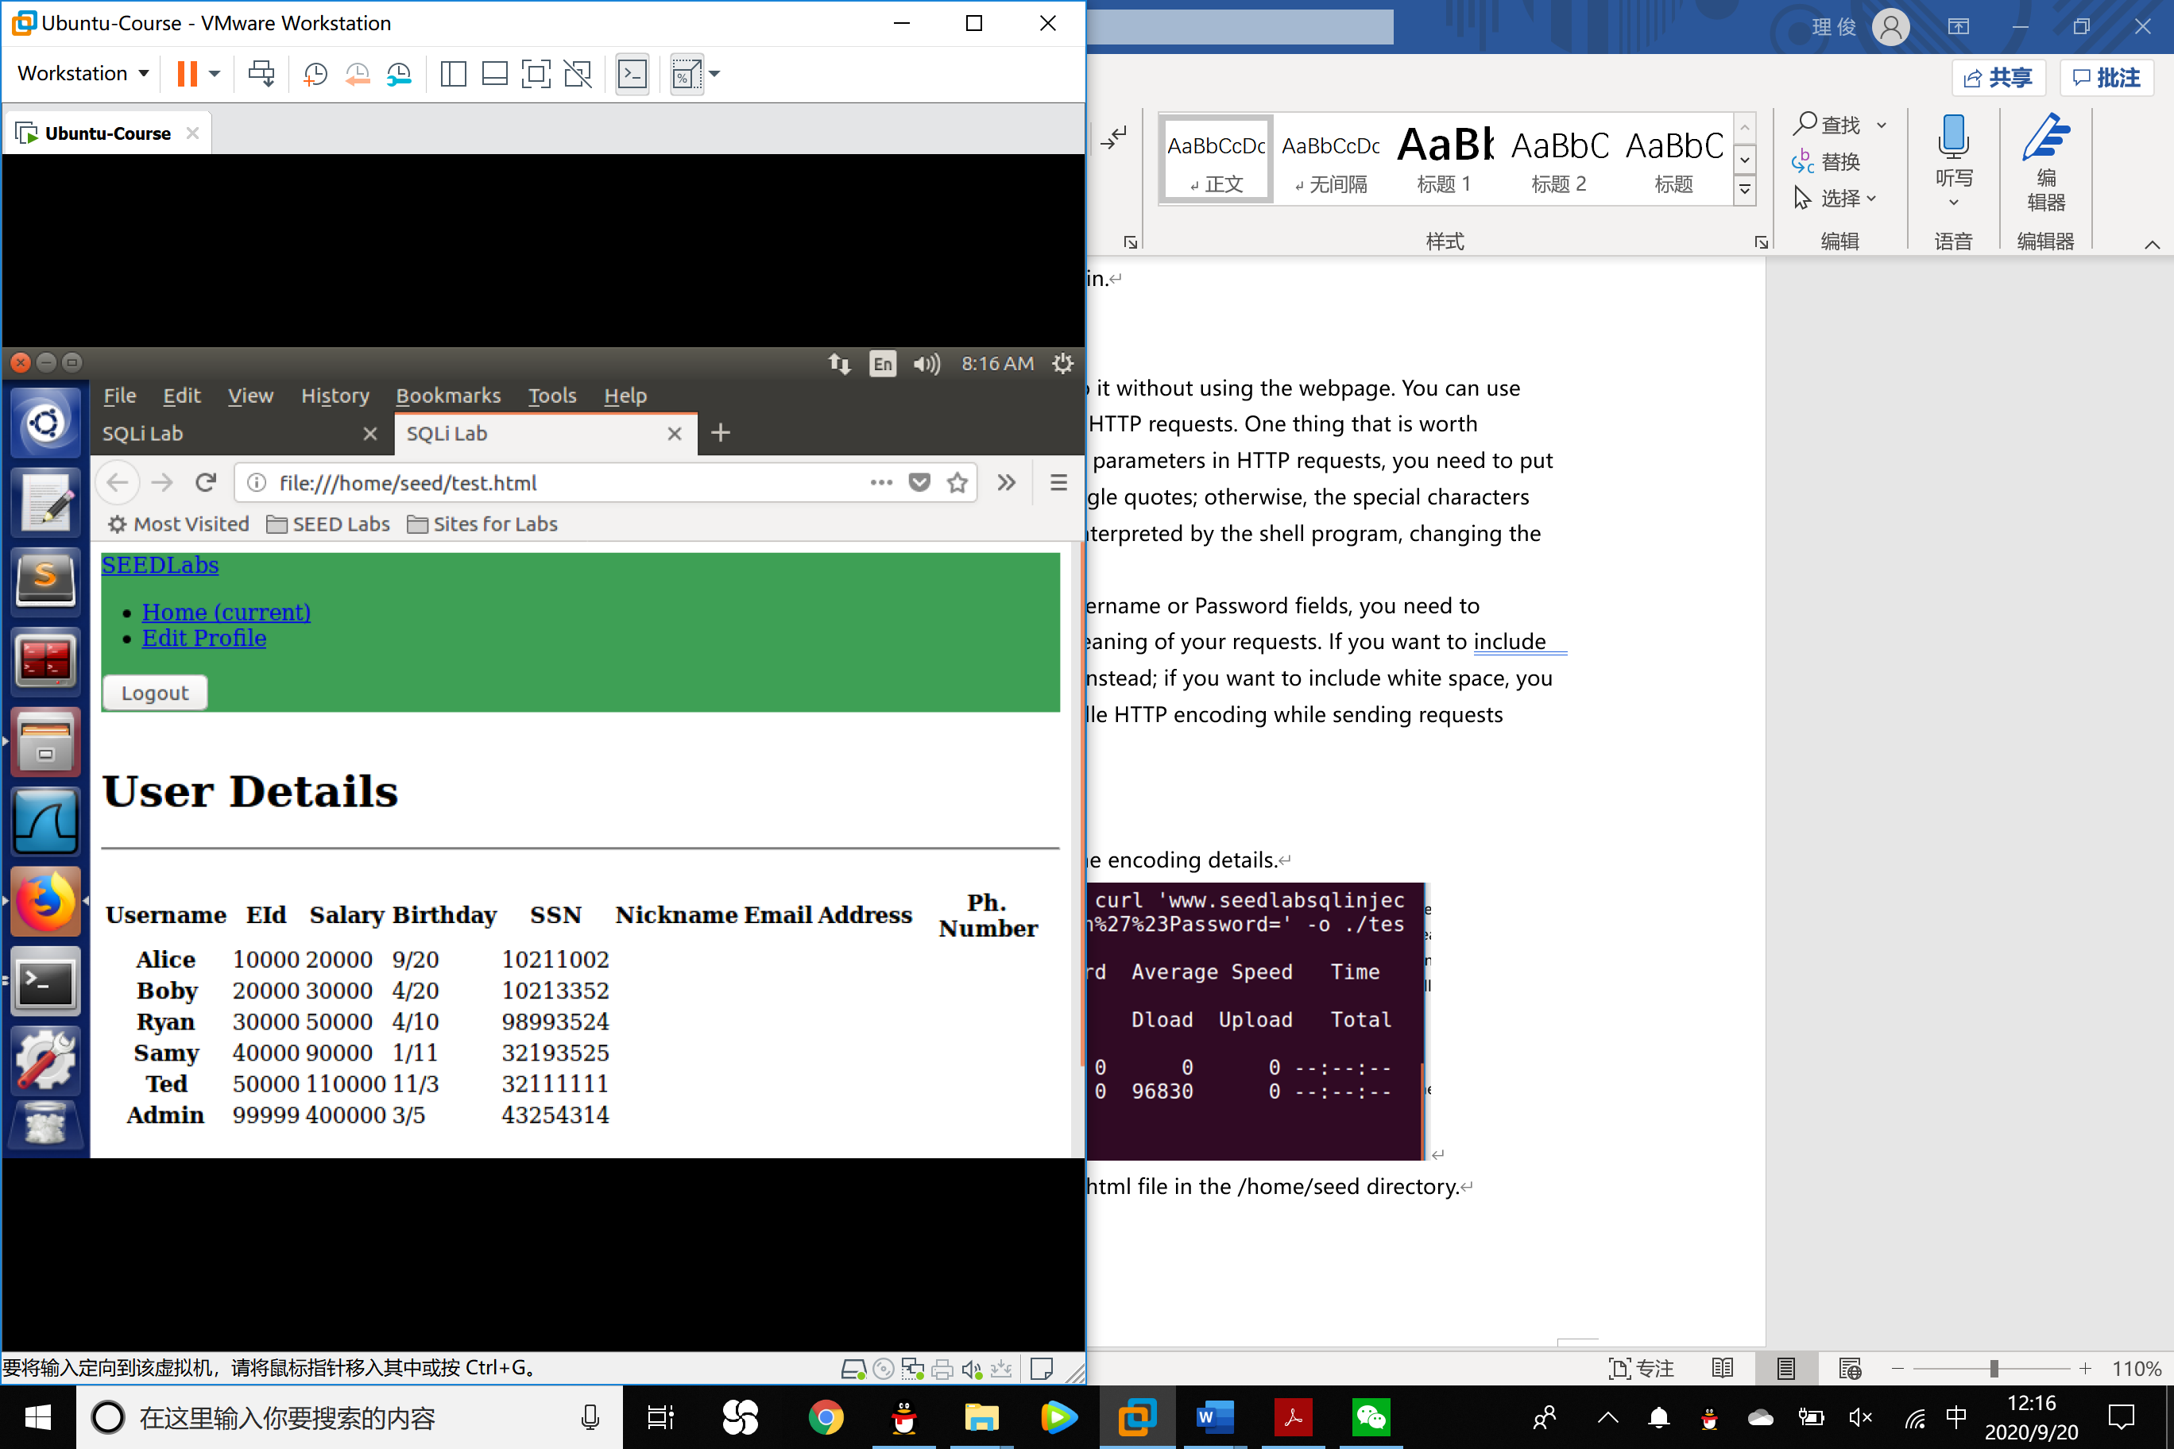

As you can see, the attack succeeded.

3. **Append a new SQL statement**

In the above two attacks, we can only steal information from the database. It will be better if we can modify the database using the same vulnerability in the login page. An idea is to use the SQL injection attack to turn one SQL statement into two, with the second one being the update or delete statement. In SQL, semicolon (;) is used to separate two SQL statements. Please describe how you can use the login page to get the server run two SQL statements. Try the attack to delete a record from the database, and describe your observation.

Experiment:

1. We input the following command to Username line:

admin';delete from credential where name='Boby'#

This way, the whole SQL code became:

SELECT id, name, eid, salary, birth, ssn, address, email, nickname, Password

FROM credential

WHERE name= ’admin’;

delete from credential where name='Boby'#;

and Password=’ ’

Then the database can first return all the messages in credential and then delete the record of Boby.

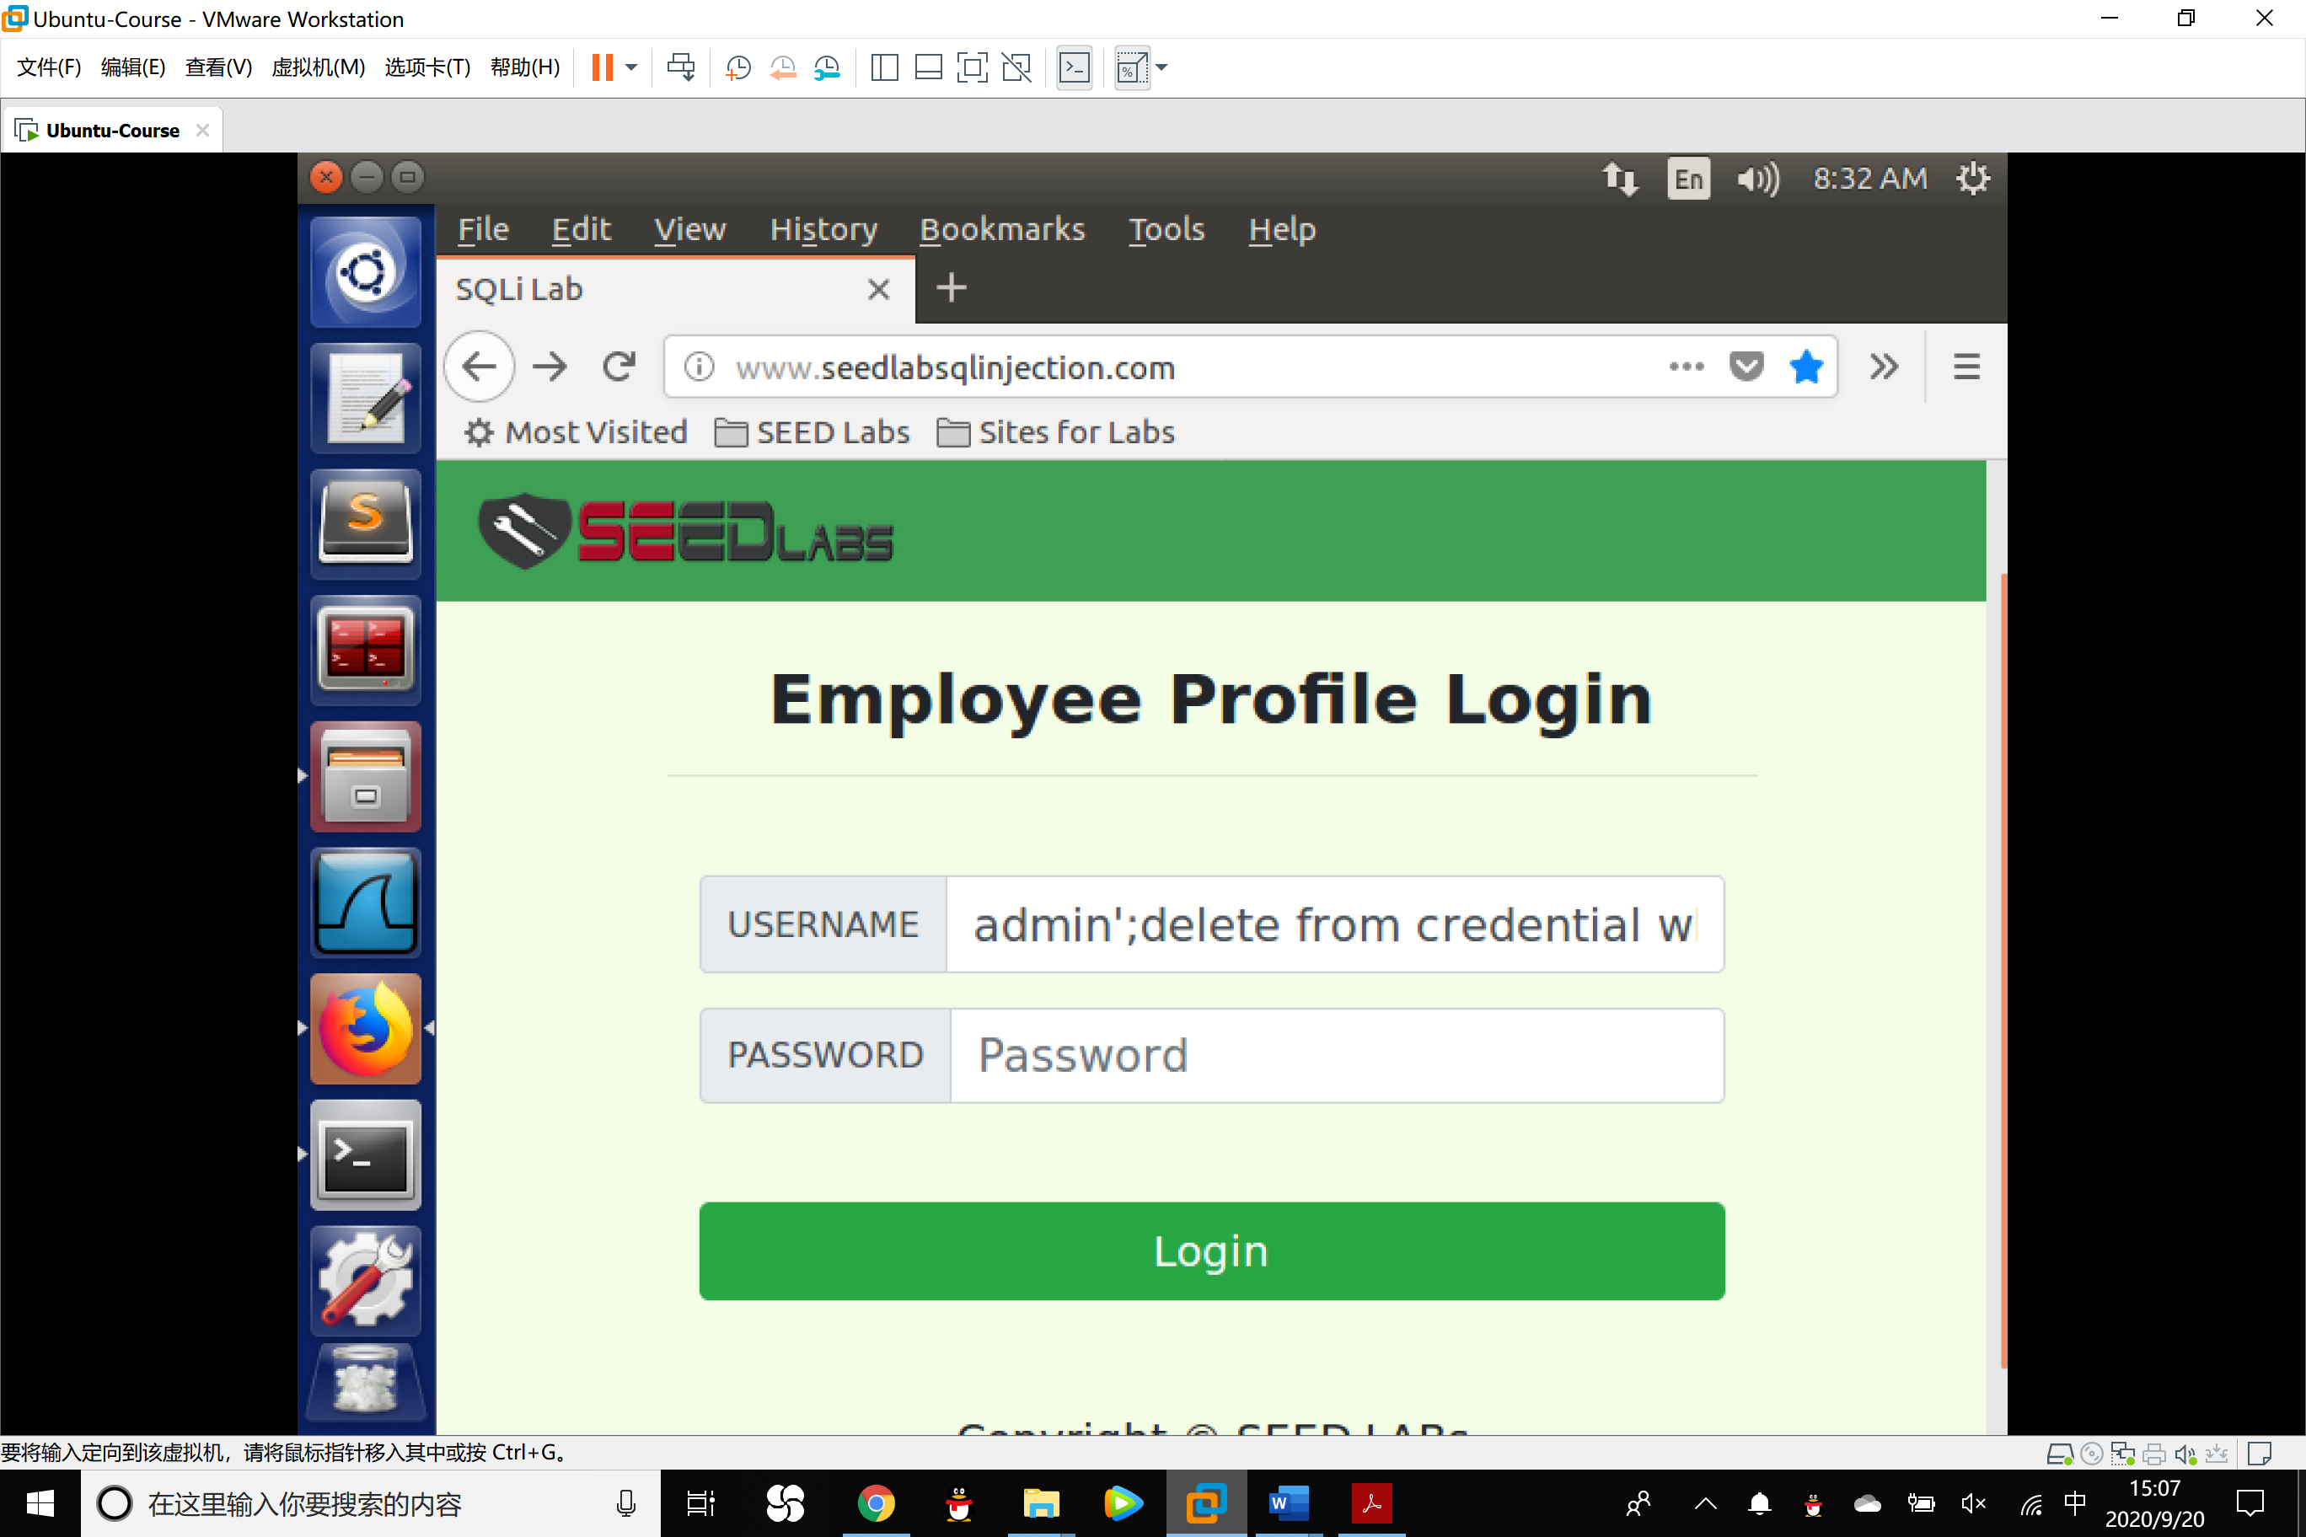

2. An error happens which shows that an error was raised when running the query.

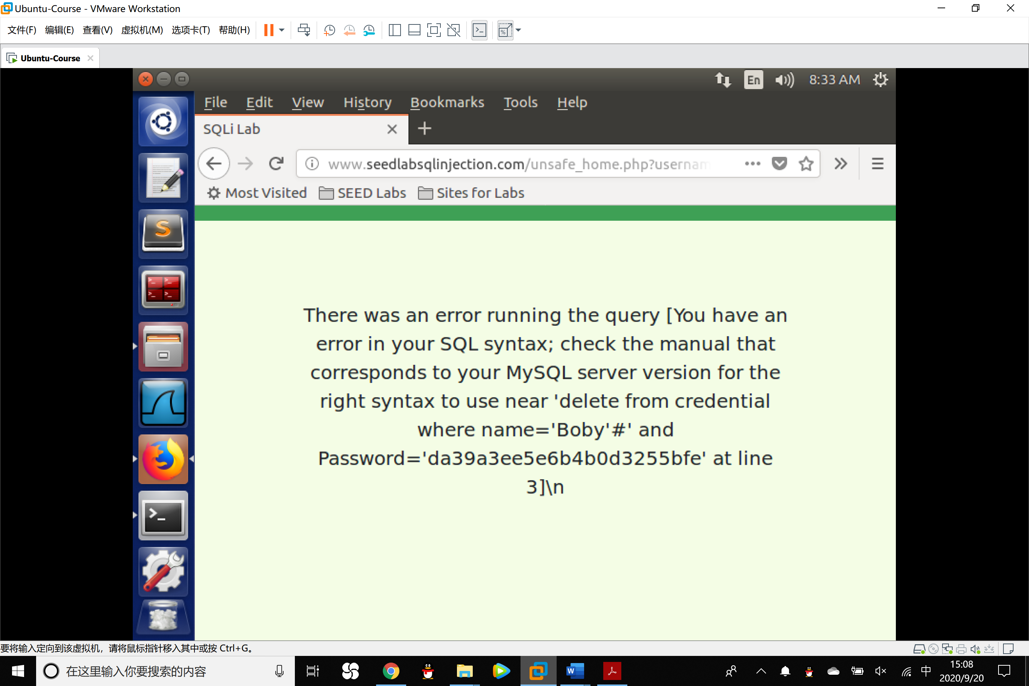

The attack failed because in the query() function of the PHP mysql expansion, it does not allow more than one SQL code to be executed. This is one of the strategy to protect the system from SQL Injection.

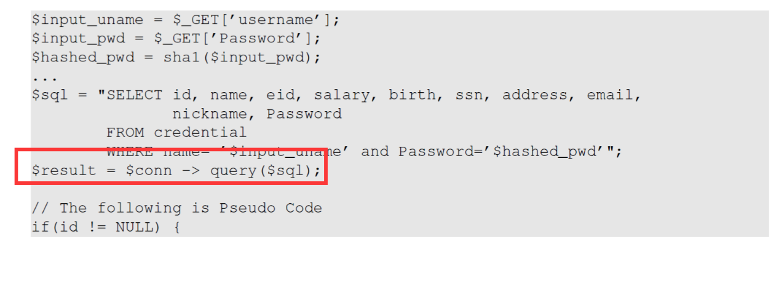

Task 3: SQL Injection Attack on UPDATE Statement

If a SQL injection vulnerability happens to an UPDATE statement, the damage will be more severe, because attackers can use the vulnerability to modify databases. In our Employee Management application, there is an Edit Profile page (Figure 2) that allows employees to update their profile information, including nickname, email, address, phone number, and password. To go to this page, employees need to log in first.

When employees update their information through the Edit Profile page, the following SQL UPDATE query will be executed. The PHP code implemented in unsafe edit backend.php file is used to update employee’s profile information. The PHP file is located in the /var/www/SQLInjection directory.

1. $hashed_pwd = sha1($input_pwd);
2. $sql = "UPDATE credential SET
3. nickname='$input_nickname',
4. email='$input_email',
5. address='$input_address',
6. Password='$hashed_pwd',
7. PhoneNumber='$input_phonenumber'
8. WHERE ID=$id;";
9. $conn->query($sql);

1. **Modify your own salary.**

As shown in the Edit Profile page, employees can only update their nicknames, emails, addresses, phone numbers, and passwords; they are not authorized to change their salaries. Assume that you (Alice) are a disgruntled employee, and your boss Boby did not increase your salary this year. You want to increase your own salary by exploiting the SQL injection vulnerability in the Edit-Profile page. Please demonstrate how you can achieve that. We assume that you do know that salaries are stored in a column called ’salary’.

Experiment:

We input Alice’,salary=688888# into the Nickname line. The database will revise the attribute of Alice according to salary=688888. The character **,** sets another attribute of Alice.

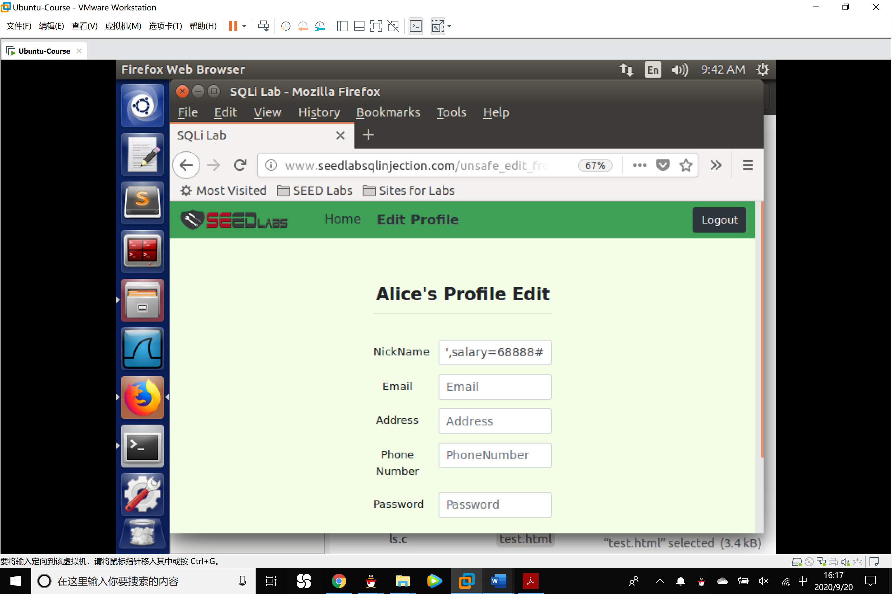

We check the profile of Alice and see that the salary has been changed.

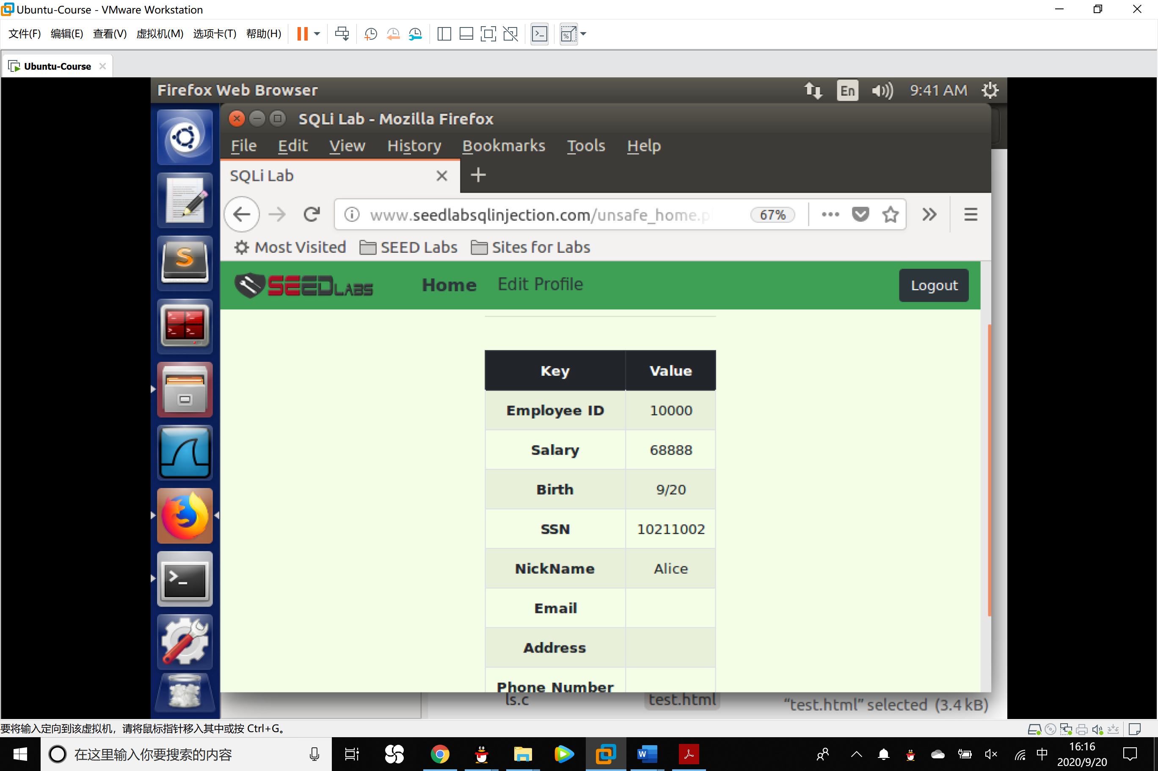

2. **Modify other people’ salary.**

After increasing your own salary, you decide to punish your boss Boby. You want to reduce his salary to 1 dollar. Please demonstrate how you can achieve that.

Experiment:

**Approach 1**

Combine the method in Task 2 and Task 3.1.

We input Boby’# to log on the account of Boby.

Then enter the page of editing the profile, input: ’,salary=1# in anyone of the blank to revise the salary of Boby.

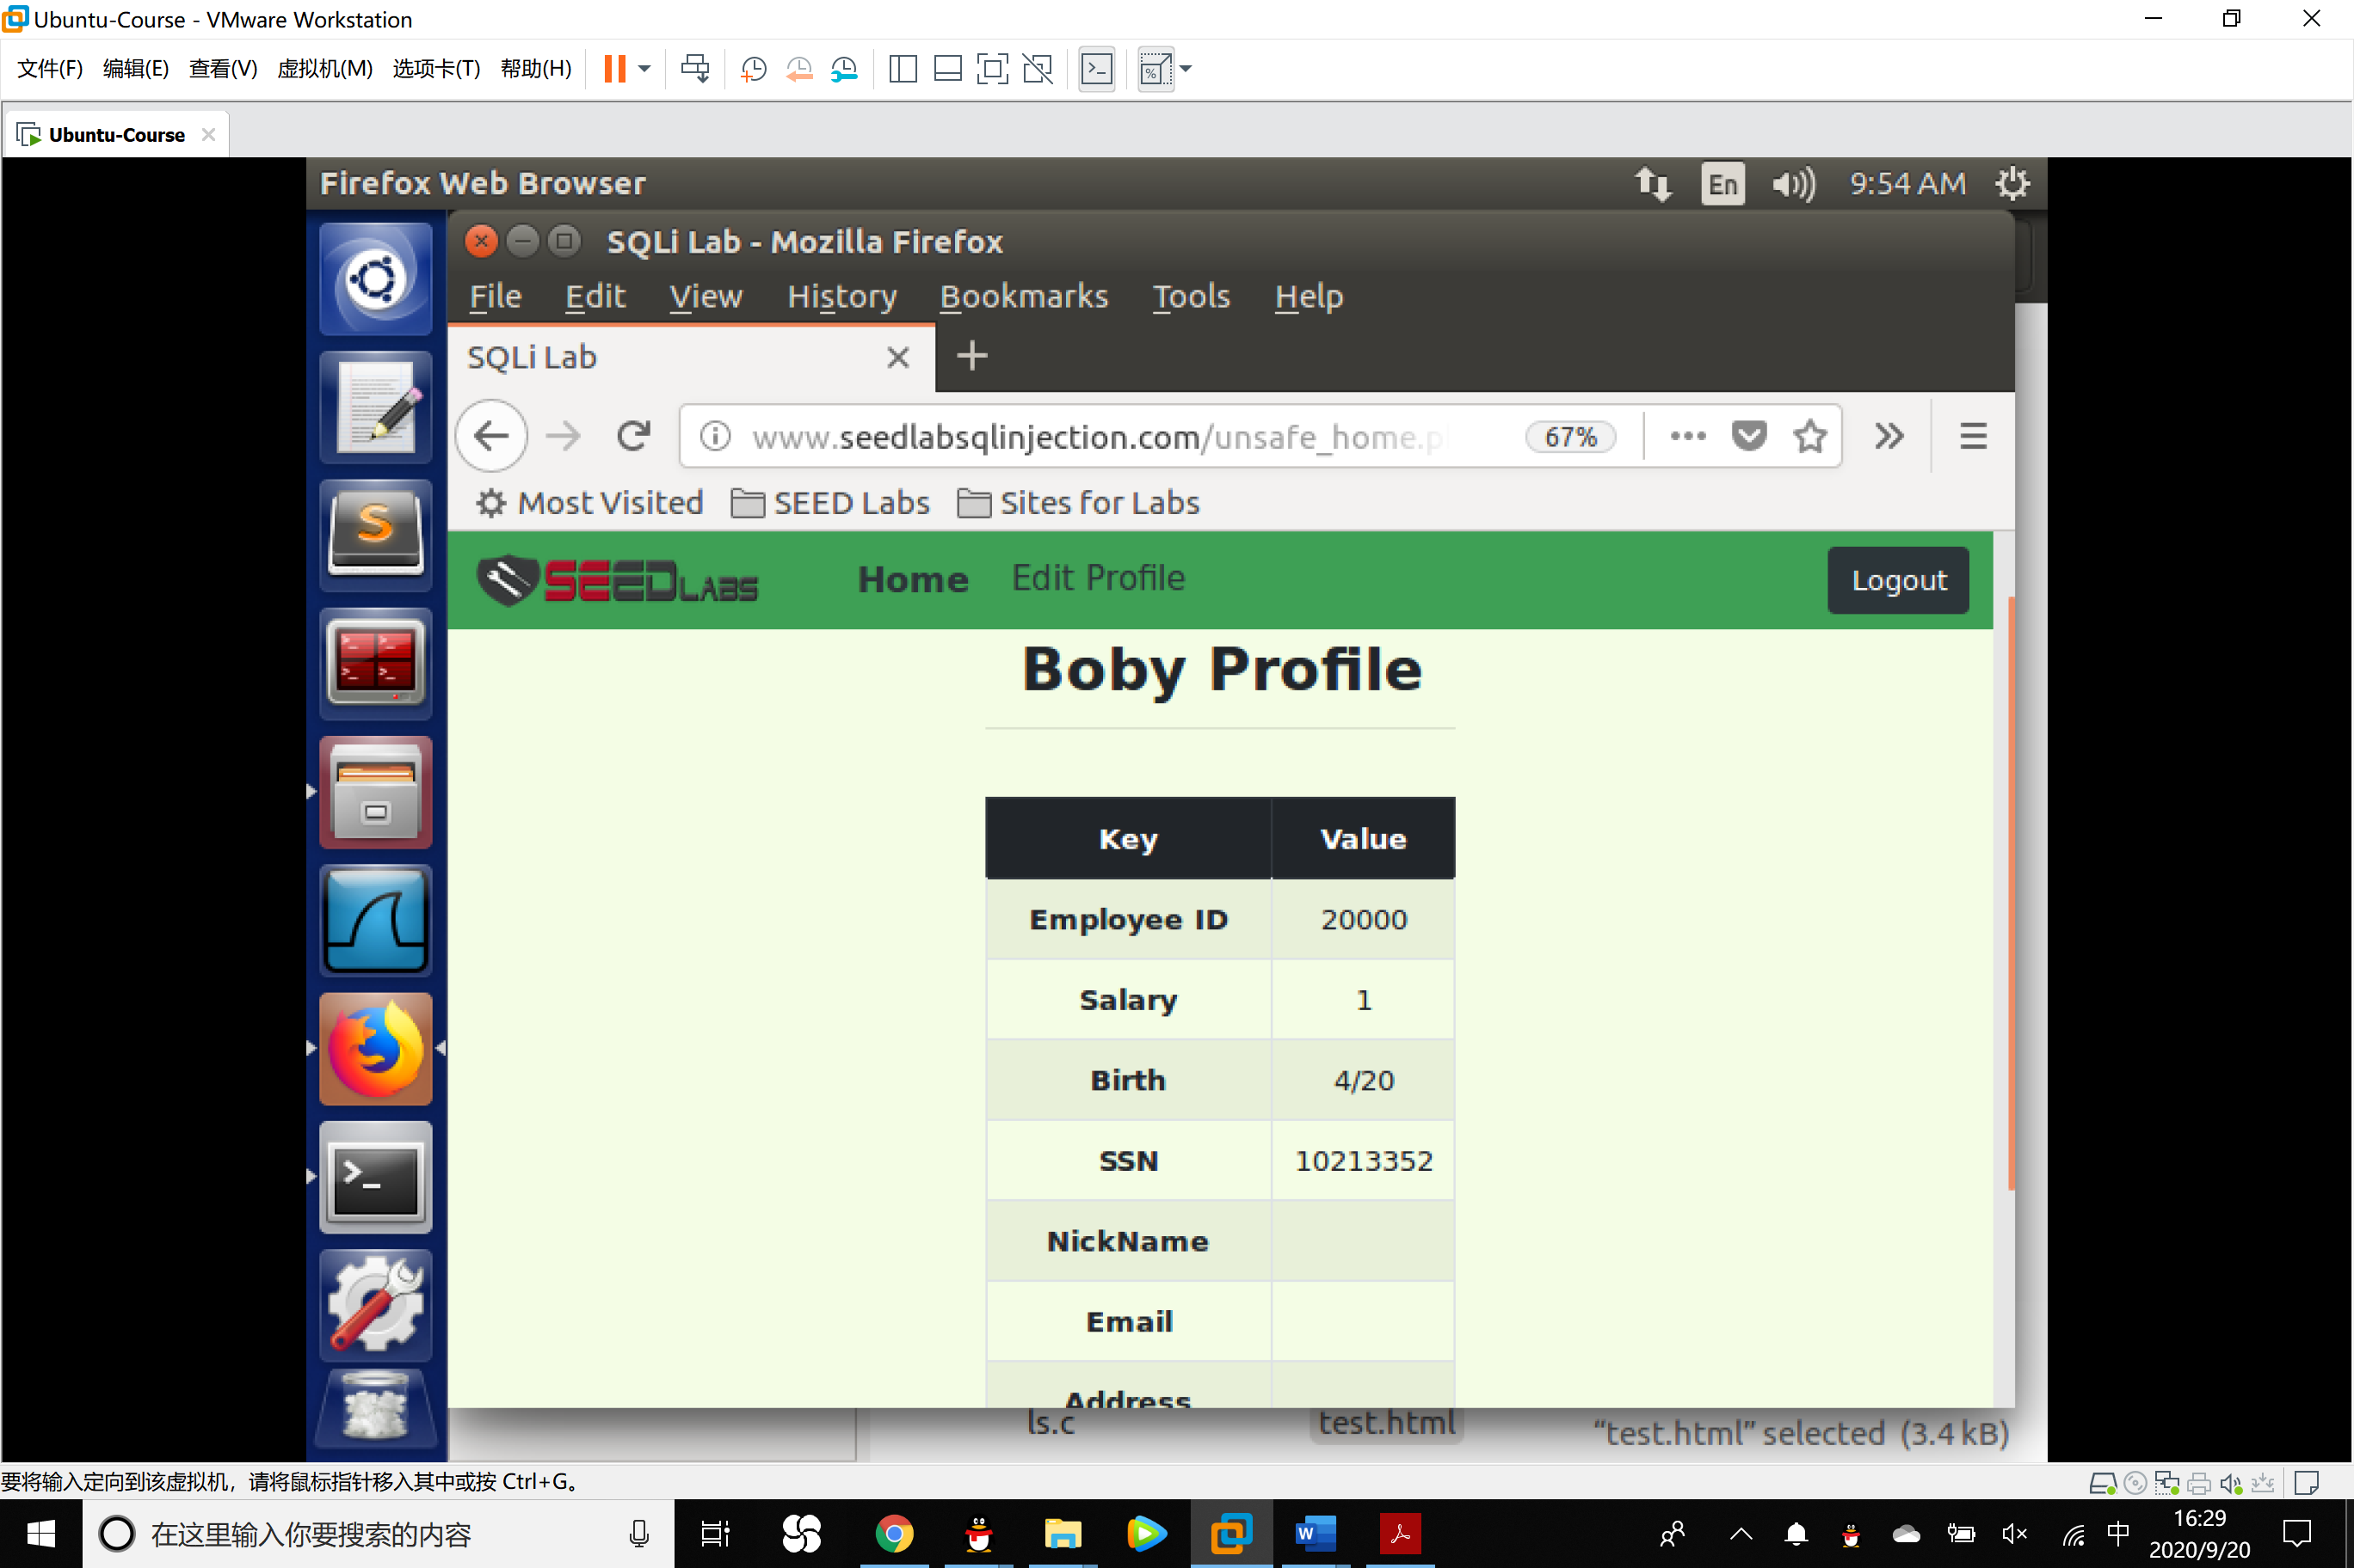

As what we have seen, the attack succeeded.

**Approach 2**

Input the following code into the Nickname blank of Alice:

',salary=2 where name='Boby'#

The database will change the salary of Boby since the where code refers to Boby and the # character comment out and disable the instruction of revising the attribute of Alice.

3. **Modify other people’ password**

After changing Boby’s salary, you are still disgruntled, so you want to change Boby’s password to something that you know, and then you can log into his account and do further damage. Please demonstrate how you can achieve that.

Experiment:

1. We want to change the password of Boby into mypass.

Input:

',Password=sha1('mypass') where name='Boby'#

Into the nickname blank of Alice.

We need to know that the dataset save the SHA hash outcome of the plain text code, so the parameter of the password should be sha1(‘mypass’).

2.When Boby uses the old password to log on his account, he failed.

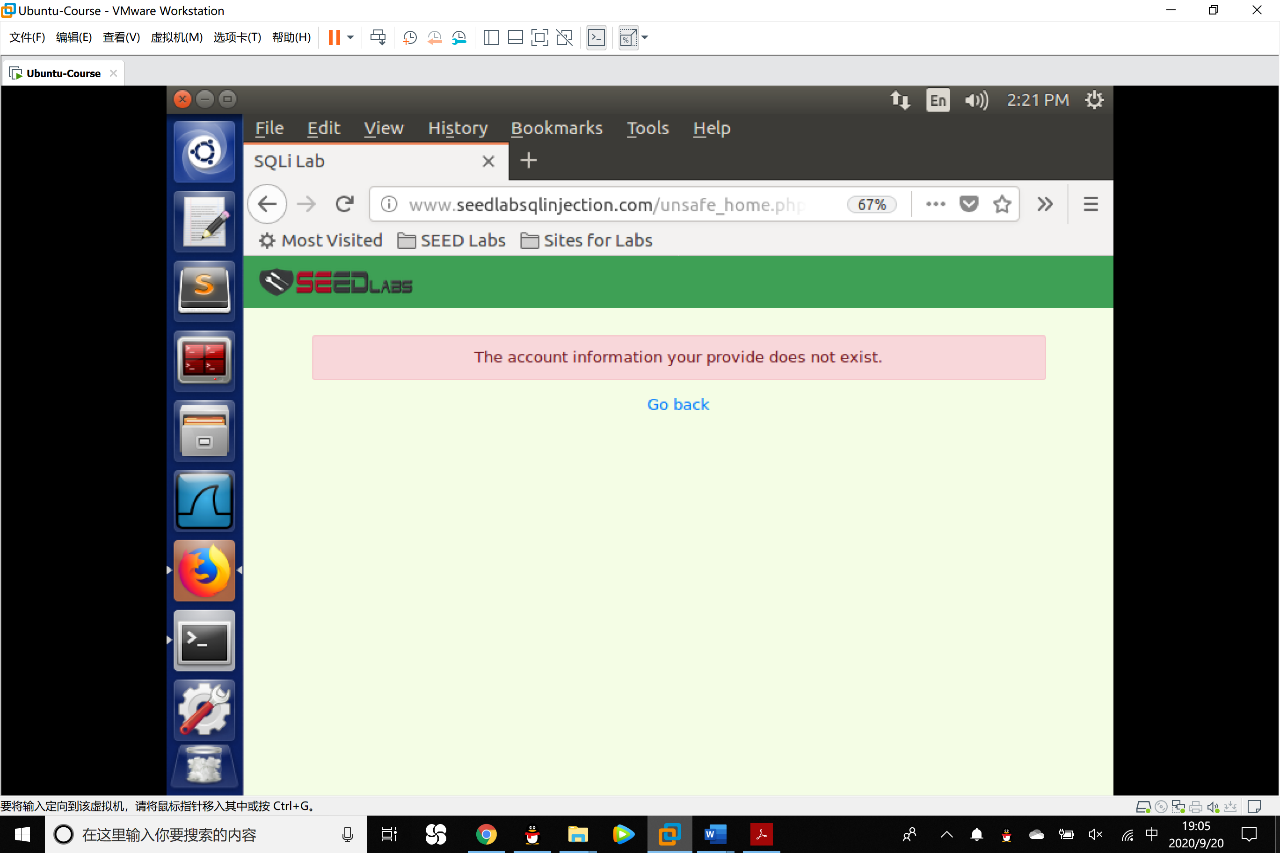

Task 4: Countermeasure — Prepared Statement

Using the prepared statement mechanism, we divide the process of sending a SQL statement to the database into two steps. For this task, please use the prepared statement mechanism to fix the SQL injection vulnerabilities exploited by you in the previous tasks. Then, check whether you can still exploit the vulnerability or not.

Experiment:

1. To use the prepared statement, we can use the following file safe_home.

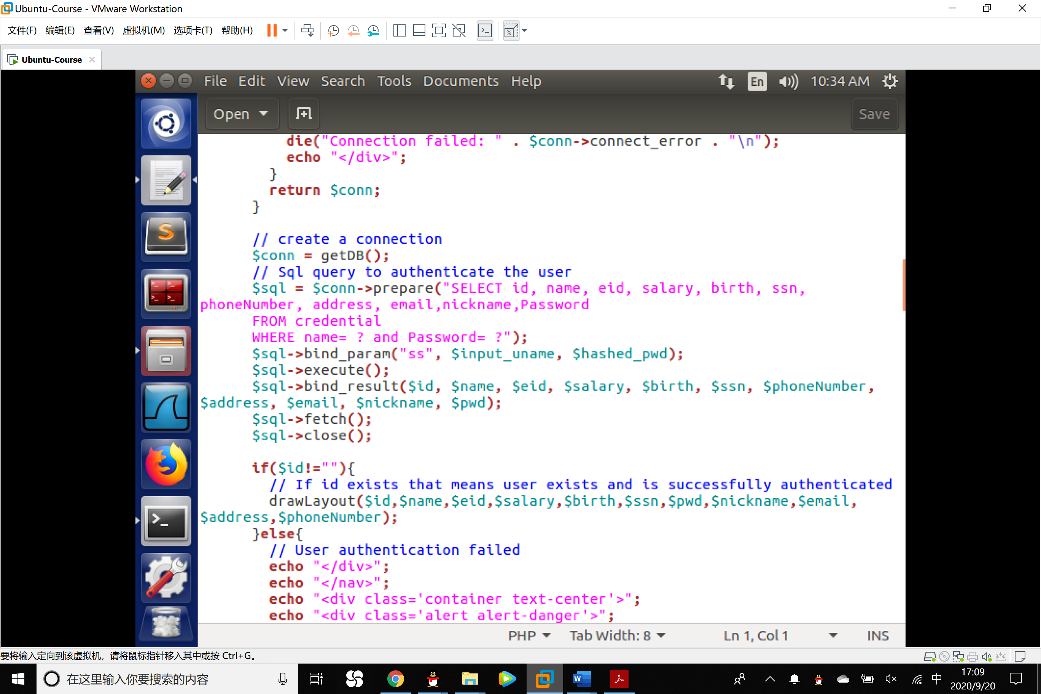

In the mechanism of prepared statement, the first step is to only send the code part, i.e., a SQL statement without the actual the data. This is the prepare step. As we can see from the above code snippet, the actual data are replaced by question marks (?). After this step, we then send the data to the database using bind param(). The database will treat everything sent in this step only as data, not as code anymore. It binds the data to the corresponding question marks of the prepared statement. In the bind param() method, the first argument "ss" indicates the types of the parameters: "s" means that the data in $input_uname has the string type, and "s" means that the data in $pwd has the string type.

2. Revising the blue square part in the file index.html at the directory of the website, change the unsafe_home.php into safe_home.php.

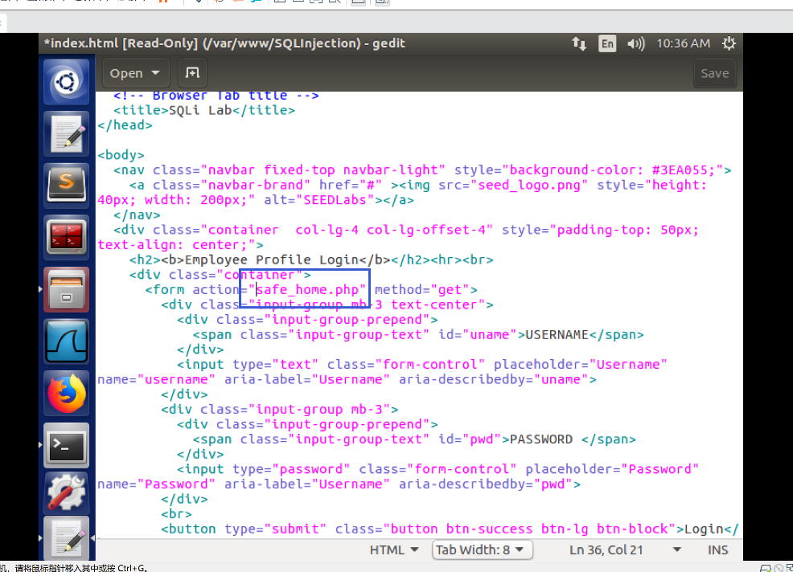

3. Save the file and try Alice’# SQL injection approach, we can see that the server regards all the input as data but no code and the page shows that the account information we provide does not exist.

